**Instruction for running this project:**

**It is deploy to host**

**It is deployed to the sever**

**Used this link This link is used for getting the data from database of particular stock data.** https://stockgraph2321.herokuapp.com/api/stockexchange/stock

**like this in postman**

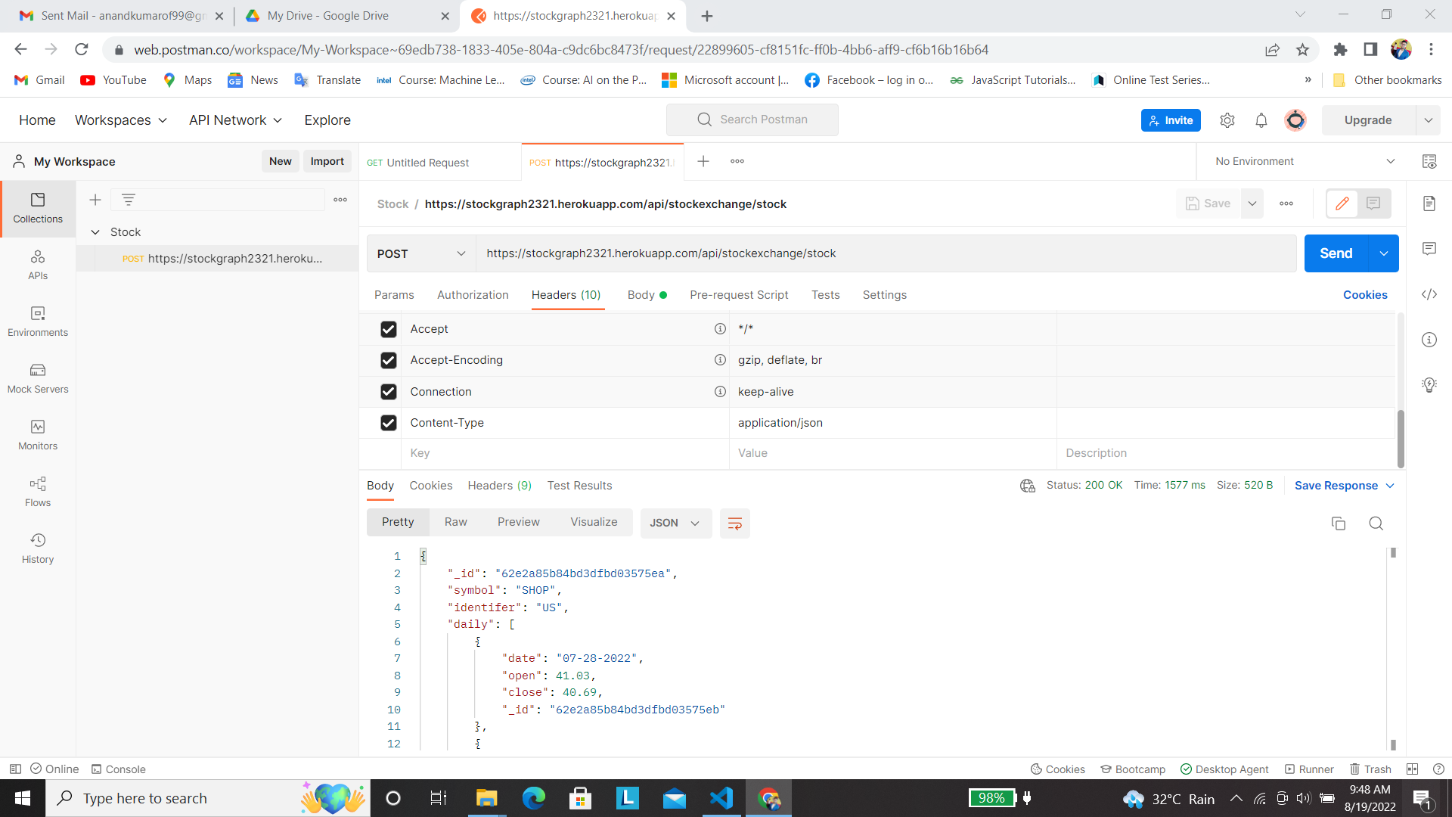

**First choose the post in the dropdown menu in the arrow suggested, then put the above link in the 2nd arrow showing.**

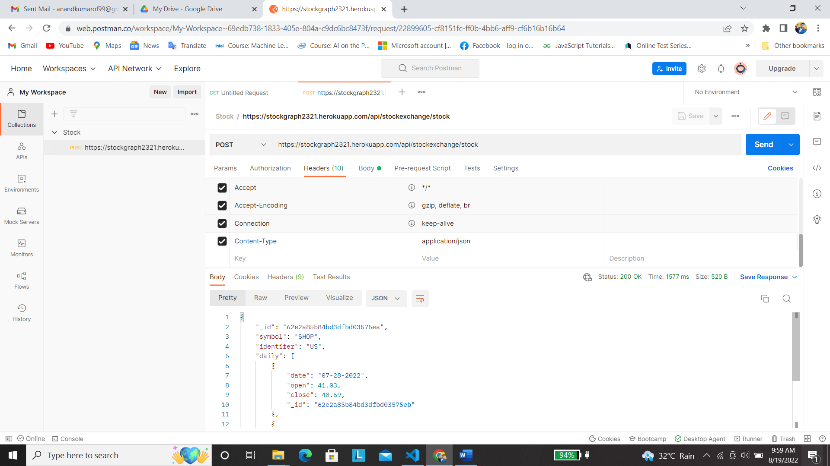

**Choose the header section as arrow displaying.**

**Type content-type and also write into another row application/json.**

**Then go to Body section.**

**The Choose the raw data then go to the 2nd arrow choose from the dropdown menu JSON. And type this in body in arrow**

**This are the different data that are store.**

**{**

**symbol: “SHOP”**

**}**

**In symbol type any of these stock in double quote SHOP, IBM, APPL,** RELIANCE.BSE

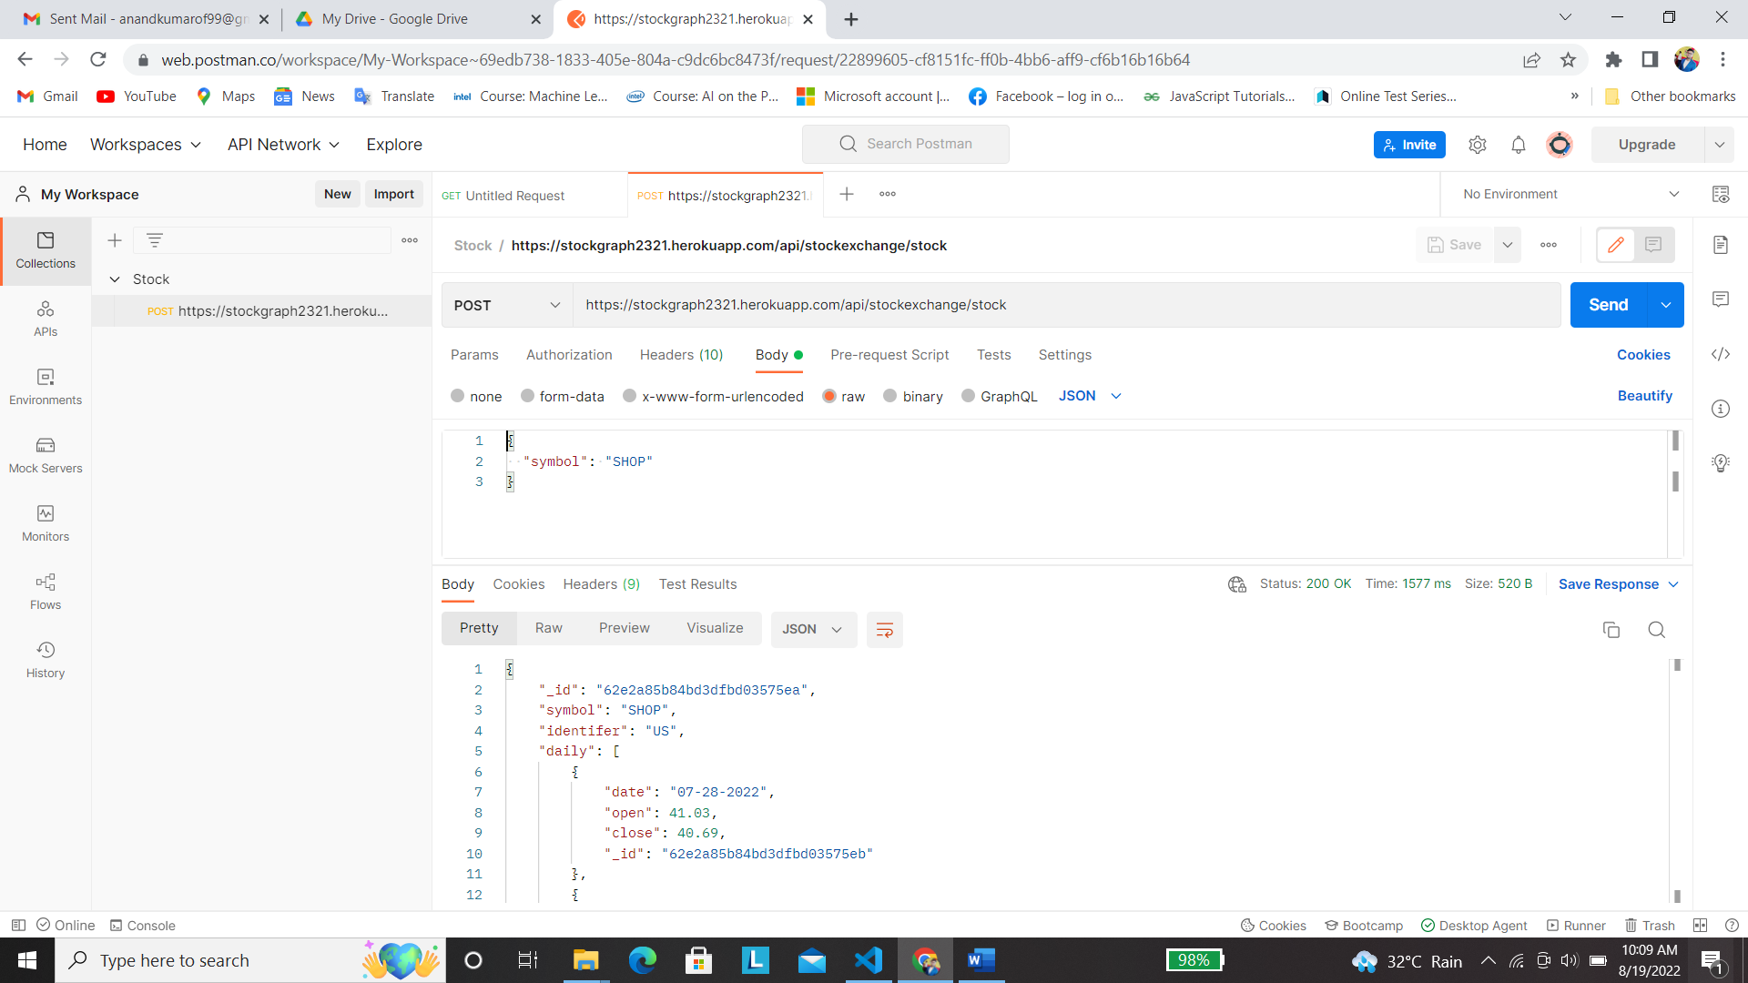

**Result will be show into the json format.**